GCP_Report
Report 28 June 2022

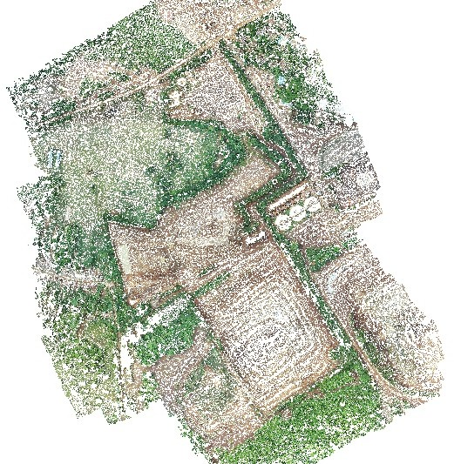

Survey Data

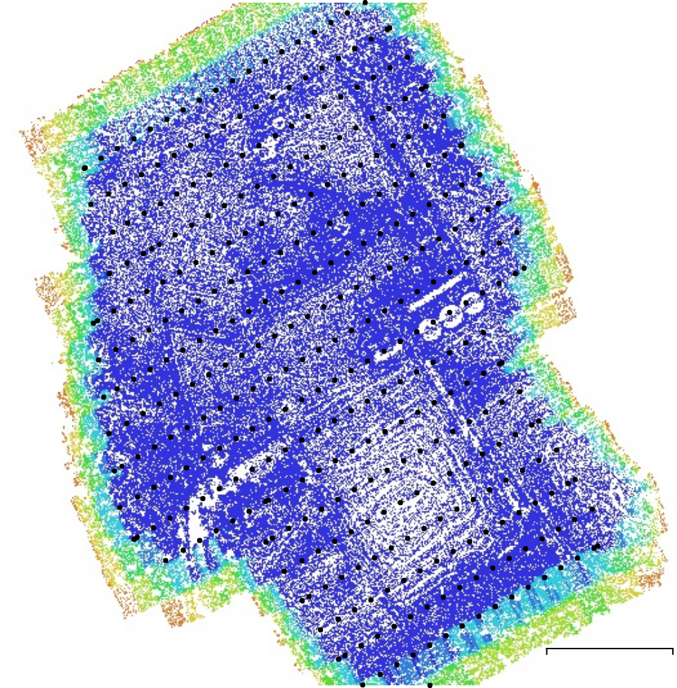
> 9
200 m
9
8
7
6
5
4
3
2
1

Fig. 1. Camera locations and image overlap.

Number of images: | 376 | Camera stations: | 376
Flying altitude: | 150 m | Tie points: | 285,128
Ground resolution: | 4.11 cm/pix | Projections: | 1,346,371
Coverage area: | 0.49 km² | Reprojection error: | 1.17 pix

Camera Model | Resolution | Focal Length | Pixel Size | Precalibrated
FC6310S (8.8mm) | 5472 x 3648 | 8.8 mm | 2.41 x 2.41 μm | No
Table 1. Cameras.

Camera Calibration
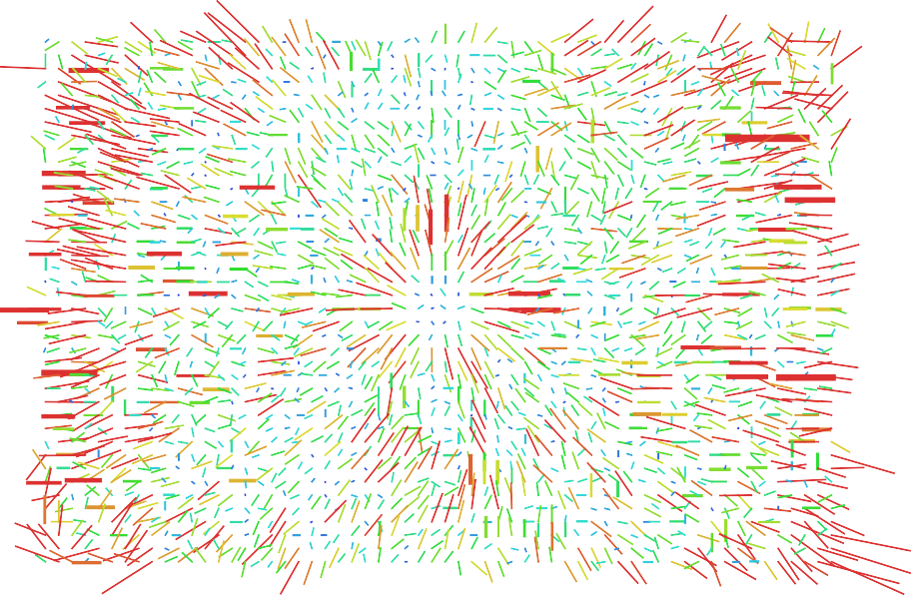

1 pix
Fig. 2. Image residuals for FC6310S (8.8mm).

FC6310S (8.8mm)
376 images
Type | Resolution | Focal Length | Pixel Size
Frame | 5472 x 3648 | 8.8 mm | 2.41 x 2.41 μm

 | Value | Error | Cx | Cy | B1 | B2 | K1 | K2 | K3 | P1 | P2
F | 3648
Cx | -23.409 | 0.15 | 1.00 | -0.02 | -0.26 | -0.43 | 0.01 | -0.03 | 0.04 | 0.35 | 0.03
Cy | -2.31474 | 0.12 |  | 1.00 | 0.39 | -0.30 | 0.02 | -0.02 | 0.02 | 0.01 | -0.43
B1 | -1.47073 | 0.019 |  |  | 1.00 | -0.00 | -0.04 | 0.00 | 0.00 | -0.04 | -0.32
B2 | -0.952641 | 0.018 |  |  |  | 1.00 | -0.02 | 0.02 | -0.02 | -0.16 | 0.07
K1 | -0.0139603 | 2.8e-05 |  |  |  |  | 1.00 | -0.96 | 0.91 | 0.01 | 0.00
K2 | 0.00258858 | 8e-05 |  |  |  |  |  | 1.00 | -0.99 | 0.00 | 0.01
K3 | 0.00583585 | 6.9e-05 |  |  |  |  |  |  | 1.00 | -0.00 | -0.01
P1 | -0.00209347 | 2.2e-06 |  |  |  |  |  |  |  | 1.00 | 0.03
P2 | -0.0014433 | 2e-06 |  |  |  |  |  |  |  |  | 1.00
Table 2. Calibration coefficients and correlation matrix.

Camera Locations

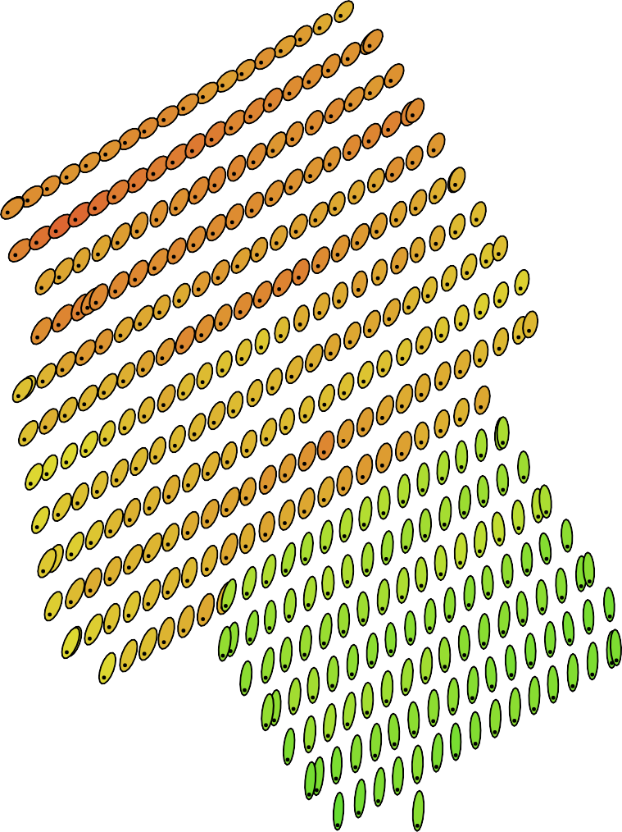
10 m
200 m
8 m
6 m
4 m
2 m
0 m
-2 m
-4 m
-6 m
-8 m
-10 m

x 6

Fig. 3. Camera locations and error estimates.
Z error is represented by ellipse color. X,Y errors are represented by ellipse shape.
Estimated camera locations are marked with a black dot.

X error (m) | Y error (m) | Z error (m) | XY error (m) | Total error (m)
1.1334 | 3.82765 | 5.75203 | 3.99193 | 7.00153
Table 3. Average camera location error. X - Longitude, Y - Latitude, Z - Altitude.

Ground Control Points

2.5 mm 2 mm
Control points
Check points
200 m
GCP15
GCP1
GCP14
GCP2
GCP9
GCP13
GCP3
1.5 mm 1 mm
0.5 mm 0 mm
-0.5 mm
-1 mm
-1.5 mm
-2 mm
-2.5 mm

x 2000

Fig. 4. GCP locations and error estimates.
Z error is represented by ellipse color. X,Y errors are represented by ellipse shape.
Estimated GCP locations are marked with a dot or crossing.

Count | X error (cm) | Y error (cm) | Z error (cm) | XY error (cm) | Total (cm)
7 | 0.655577 | 1.19515 | 0.144706 | 1.36315 | 1.37081
Table 4. Control points RMSE.
X - Longitude, Y - Latitude, Z - Altitude.

Label | X error (cm) | Y error (cm) | Z error (cm) | Total (cm) | Image (pix)
GCP1 | -0.268927 | 0.869543 | 0.0937187 | 0.914992 | 0.473 (10)
GCP2 | 0.372561 | -2.32387 | 0.0471326 | 2.35402 | 0.835 (10)
GCP3 | 1.11684 | -0.264841 | -0.173266 | 1.16082 | 0.558 (10)
GCP9 | -0.634555 | 1.30599 | -0.123274 | 1.45721 | 0.554 (10)
GCP13 | -1.01235 | -0.253993 | 0.237379 | 1.07038 | 0.527 (10)
GCP14 | 0.335421 | 1.28759 | -0.178645 | 1.3425 | 0.747 (10)
GCP15 | 0.0999618 | -0.586587 | 0.0457444 | 0.5968 | 0.350 (10)
Total | 0.655577 | 1.19515 | 0.144706 | 1.37081 | 0.597
Table 5. Control points.
X - Longitude, Y - Latitude, Z - Altitude.

